**C-DAC Mumbai Date 29/09/2024**

**Subject: Algorithm and Data Structure**

**Assignment 3**

**Solve the assignment with following thing to be added in each question.**

-Program

-Flow chart

-Explanation

-Output

-Time and Space complexity

**1. Implement a Stack using an array.**

* **Test Case 1**:  
  Input: Push 5, 3, 7, Pop  
  Output: Stack = [5, 3], Popped element = 7
* **Test Case 2**:  
  Input: Push 10, Push 20, Pop, Push 15  
  Output: Stack = [10, 15], Popped element = 20

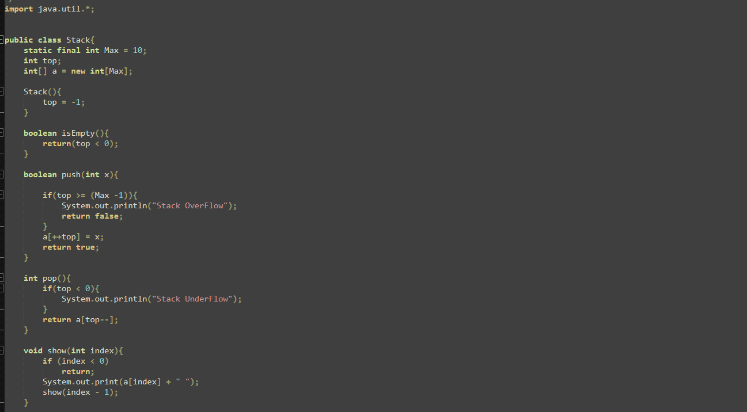

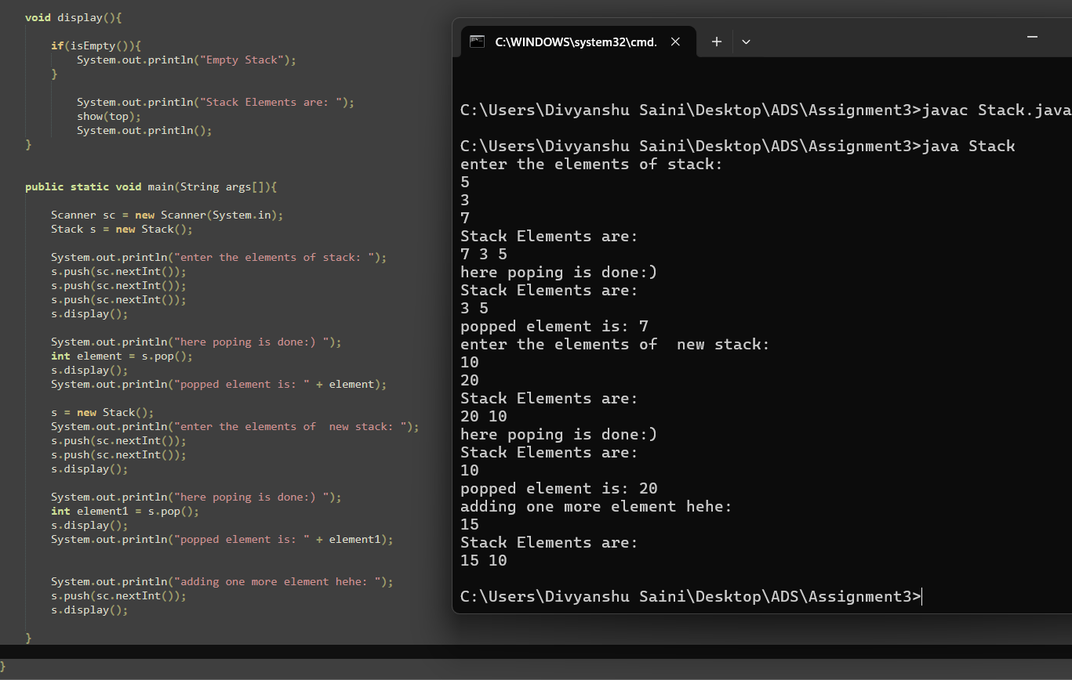

**Flowchart-**

**Start**

|

|

**Initialize Stack**

**|**

**Check if Stack is Full?**

**|**

**|**

**Yes No**

**| |**

**Display "Stack Push Element**

**is Full"**

**|**

**Check if Stack is Empty?**

**|**

**Yes No**

**| |**

**Display "Stack Pop Element**

**is Empty”**

**| |**

**Display Elements Display Elements**

**|**

**End**

**Explanation –** Firstly I’ve created the Stack class. The stack has a maximum size defined by the constant MAX, set to 10. The class includes methods for stack operations like isEmpty() which checks if the stack is empty, push(int x) which adds an element to the top of the stack, and pop() removes and returns the top element. If the stack is full during a push operation, a message is displayed that indicates that the stack is full. If a pop operation is tried on an empty stack, a message indicates that the stack is empty. The display() method prints the current elements of the stack. In the main method I’ve taken the input from user using Scanner class and invoked the stack operations.

**Time Complexity:** Push : O(1), Pop: O(1), Peek: O(1), Display: O(n)

**Space Complexity:** O(n)

**2. Check for balanced parentheses using a stack.**

* **Test Case 1**:  
  Input: "({[()]})"  
  Output: Balanced
* **Test Case 2**:  
  Input: "([)]"  
  Output: Not Balanced

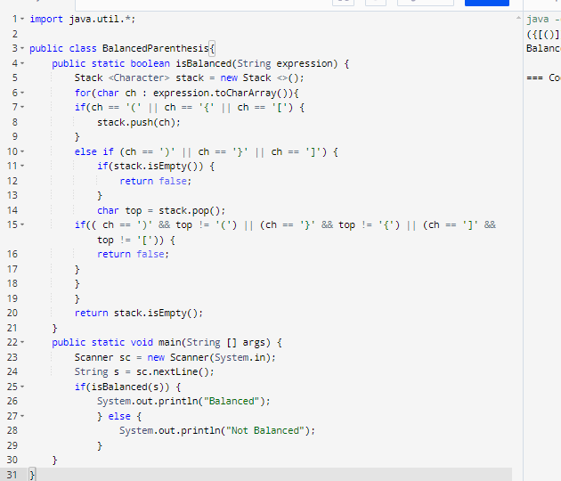



**Flowchart-**

**Start**

**|**

**Initialize an empty Stack**

**|**

**For each character in the expression**

**|**

**Is it an opening parenthesis?**

**|**

**Yes -> Push it onto the Stack**

**|**

**Is it a closing parenthesis?**

**Yes -> Is the Stack empty?**

**|**

**Yes -> Not Balanced (Stop)**

**|**

**No -> Pop from the Stack**

**|**

**Is it a matching pair?**

**|**

**No -> Not Balanced (Stop)**

**|**

**After checking all characters**

**|**

**Is the Stack empty?**

**|**

**Yes -> Balanced**

**|**

**No -> Not Balanced**

**|**

**End**

**Explanation -** The isBalanced method takes a string expression and iterates through each character. If the character is an opening parenthesis it is pushed onto the stack. If the character is a closing parenthesis the program first checks if the stack is empty. If the stack is empty the method returns false. If the stack isn't empty, the program pops the top element and checks if it matches the current closing parenthesis. If there's a mismatch, the method returns false. Once all characters have been processed, the method checks if the stack is empty. If it is, it means all parentheses were matched correctly, and the method returns true. If not, it returns false. In the main method, a Scanner is used to take input from the user, which is passed to the isBalanced method. The result is printed, indicating whether the input expression is balanced or not.

**Time Complexity:**  O(n)

**Space Complexity:** O(n)

**3. Reverse a string using a stack.**

* **Test Case 1**:  
  Input: "hello"  
  Output: "olleh"
* **Test Case 2**:  
  Input: "world"  
  Output: "dlrow"

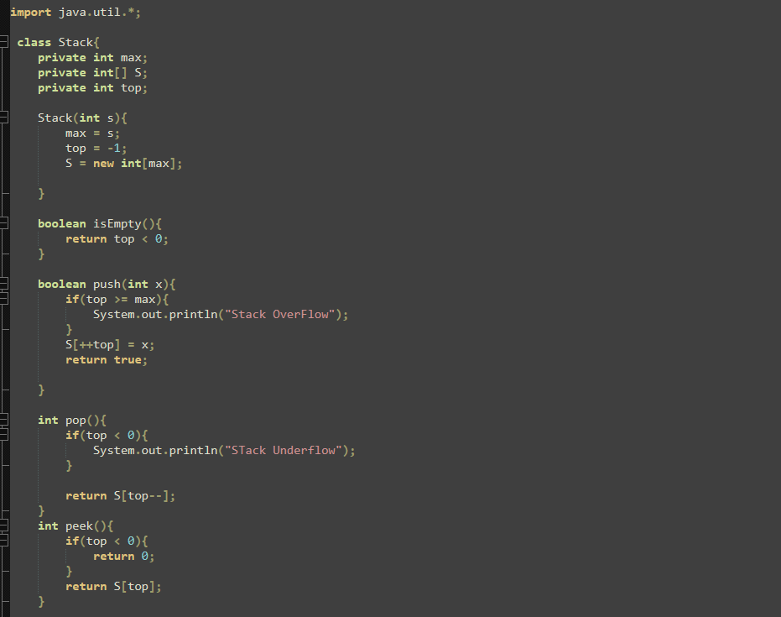

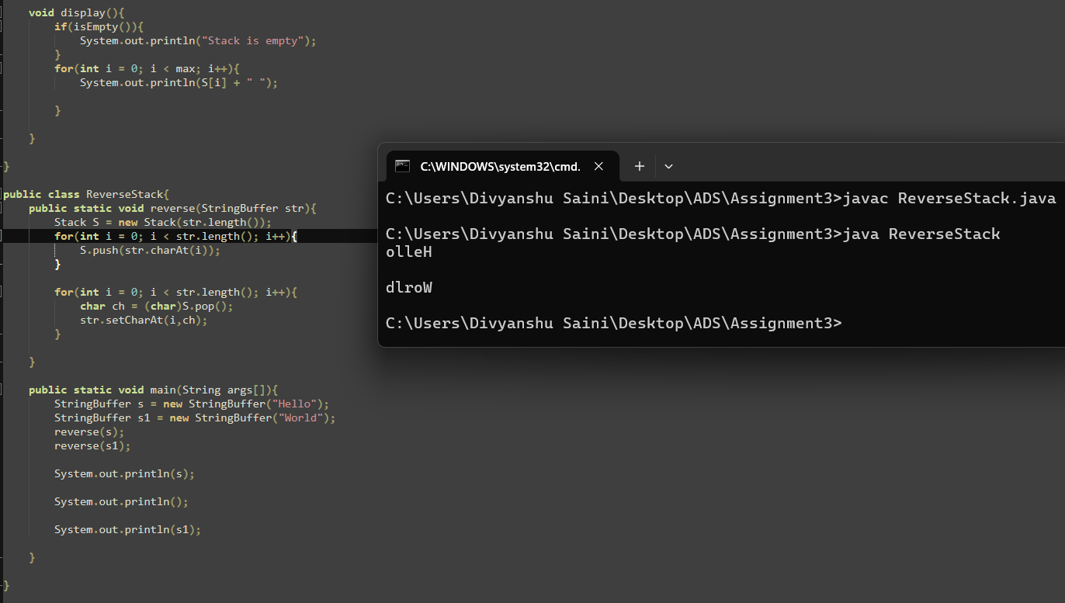

**Flowchart:**

**Start**

|

**Initialize Stack S**

**with max capacity**

|

**For each character in the string**

**Push character onto Stack S**

|

**For each position in the string**

**Pop character from Stack S**

**Replace character at current position**

|

**Display Reversed**

**String**

|

**End**

**Explanation-** A Stack object is created with a size equal to the length of the string. The program iterates through each character of the input string and pushes them into the stack one by one. In the next phase, the program iterates through the string positions again, this time popping characters from the stack and replacing the original string's characters in reverse order. Finally, the reversed string is displayed. In the main method I’ve created the object of StringBuffer class and invoked the reversed string.

**Time Complexity:** O(n)

**Space Complexity:** O(n)

**4. Evaluate a postfix expression using a stack.**

* **Test Case 1**:  
  Input: "5 3 + 2 *"  
  Output: 16
* **Test Case 2**:  
  Input: "4 5 * 6 /"  
  Output: 3

**5. Convert an infix expression to postfix using a stack.**

* **Test Case 1**:  
  Input: "A + B * C"  
  Output: "A B C * +"
* **Test Case 2**:  
  Input: "A * B + C / D"  
  Output: "A B * C D / +"

**6. Implement a Queue using an array.**

* **Test Case 1**:  
  Input: Enqueue 5, Enqueue 10, Dequeue  
  Output: Queue = [10], Dequeued element = 5
* **Test Case 2**:  
  Input: Enqueue 1, 2, 3, Dequeue, Dequeue  
  Output: Queue = [3], Dequeued elements = 1, 2

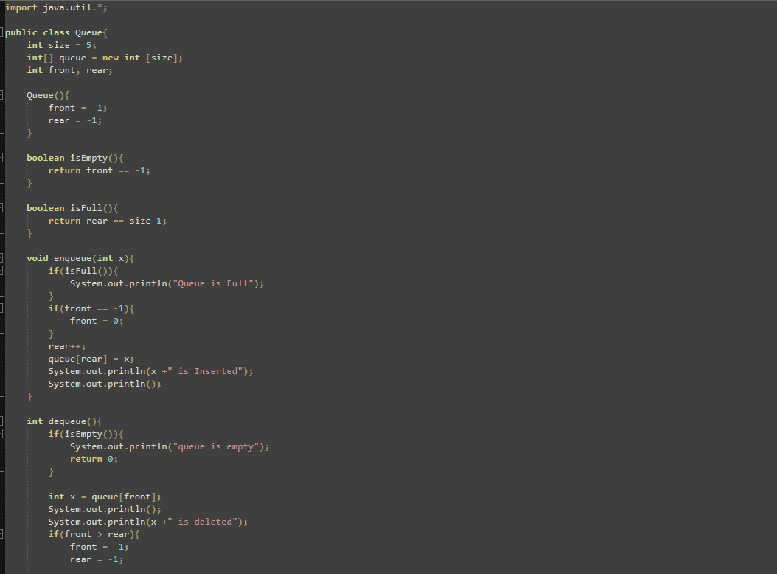

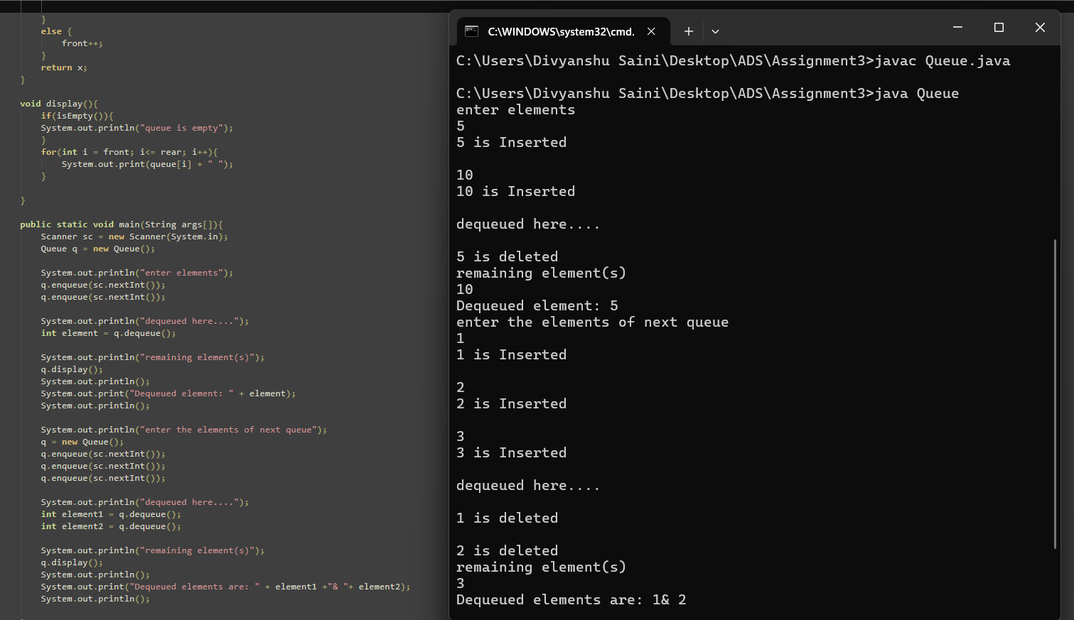

**Flowchart -**

**START**

|

**Initialize size = 5, queue[size], front = -1, rear = -1**

|

**Main Menu**

**Enqueue**

**Dequeue**

**Display**

**Exit** |

**If option = 1 (Enqueue)**

|

**Check if (rear == size - 1)**

|

/ \

**Yes No**

| |

**Display Check if (front == -1)**

**"Queue is full"**

**Yes No**

| |

**Return Set Increament rear**

**front = 0 queue[rear] = x**

**Display "x is inserted"**

|

**Return to Main Menu**

**If option = 2 (Dequeue**)

|

**Check if (front == -1)**

|

/ \

**Yes No**

| |

**Display Set x = queue[front]**

**"Queue is empty" Display "x is deleted"**

**Check if (front > rear)**

/ \

**Yes No**

| |

**Return Set front=-1 Increment front**

**& rear=-1**

|

**Return to Main Menu**

**If option = 3 (Display)**

|

**Check if (front == -1)**

|

/ \

**Yes No**

| |

**Display Iterate from i = front to rear**

**"Queue Print queue[i]**

**is empty"**

|

**Return to Main Menu**

**If option = 4 (Exit)**

|

**Display "Exiting the program"**

|

**END**

**Explanation –** In the Queue program I’ve initialized an array with a fixed size of 5. The front and rear variables track the front and rear positions of the queue, initialized to -1. In the enqueue method, when an element is added, the program first checks if the queue is full . If not, it sets front to 0 if it's the first element and then increments rear to add the element at the next position. The element is stored in the queue array, and a message confirms the insertion. The dequeue method checks if the queue is empty. If the queue is not empty, it retrieves and removes the element at the front position, displays the removed element, and increments front. If front exceeds rear after the removal, both front and rear are reset to -1 to indicate the queue is now empty again. The display method iterates from front to rear to show all the elements currently in the queue. The main method handles user input.

**Time Complexity:** Enqueue : 0(1) , Dequeue: O(1), display: O(n)

**Space Complexity:** O(n)

**7. Implement a Circular Queue using an array.**

* **Test Case 1**:  
  Input: Enqueue 4, 5, 6, 7, Dequeue, Enqueue 8  
  Output: Queue = [8, 5, 6, 7]
* **Test Case 2**:  
  Input: Enqueue 1, 2, 3, 4, Dequeue, Dequeue, Enqueue 5  
  Output: Queue = [5, 3, 4]

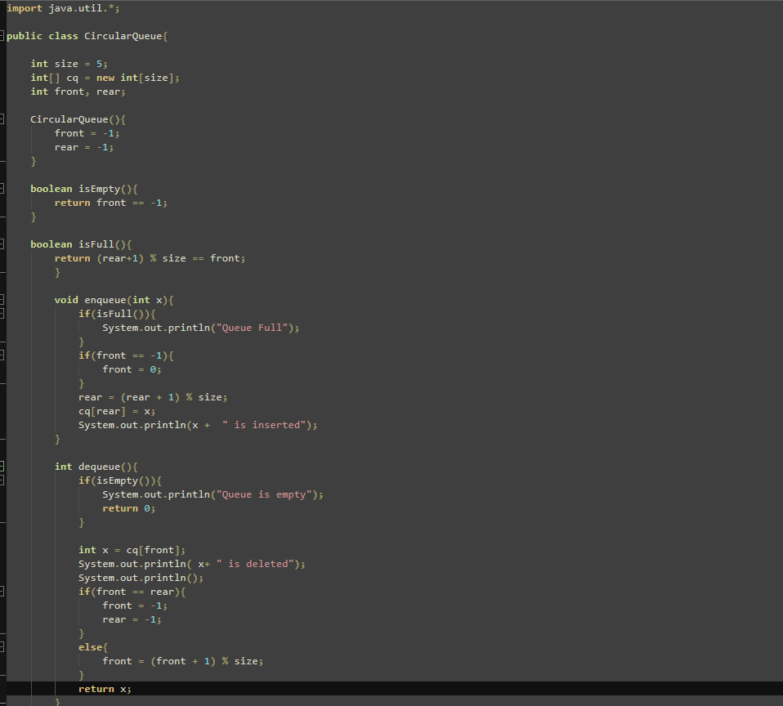

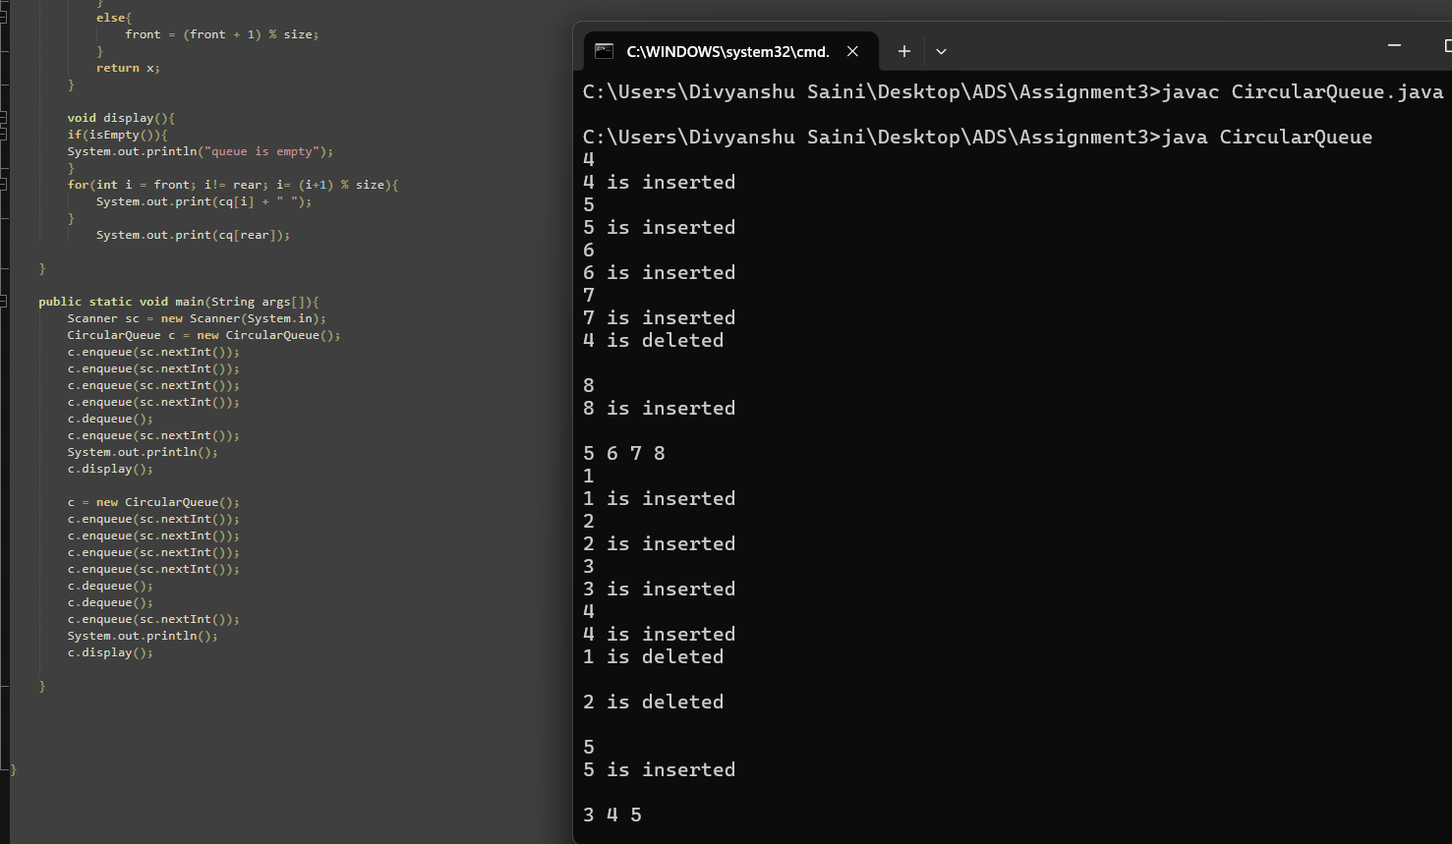

**Explanation -** In the Circular Queue program I’ve initialized an array with a fixed size of 5. The front and rear variables track the front and rear positions of the queue, initialized to -1. The isEmpty method checks whether the queue is empty by returning true. The isFull method checks if the queue is full The enqueue method inserts an element x into the queue. If the queue is full, it displays "Queue is full." If front is -1, it sets front to 0 to indicate the start of the queue. The dequeue method removes an element from the queue. If the queue is empty it displays "Queue is empty." The display method prints the elements from front to rear in a circular manner, iterating from front to rear.

**Time Complexity:** Enqueue : 0(1) , Dequeue: O(1), display: O(n)

**Space Complexity:** O(n)

**8. Implement a Queue using two Stacks.**

* **Test Case 1**:  
  Input: Enqueue 3, Enqueue 7, Dequeue  
  Output: Queue = [7], Dequeued element = 3
* **Test Case 2**:  
  Input: Enqueue 10, 20, Dequeue, Dequeue  
  Output: Queue = [], Dequeued elements = 10, 20

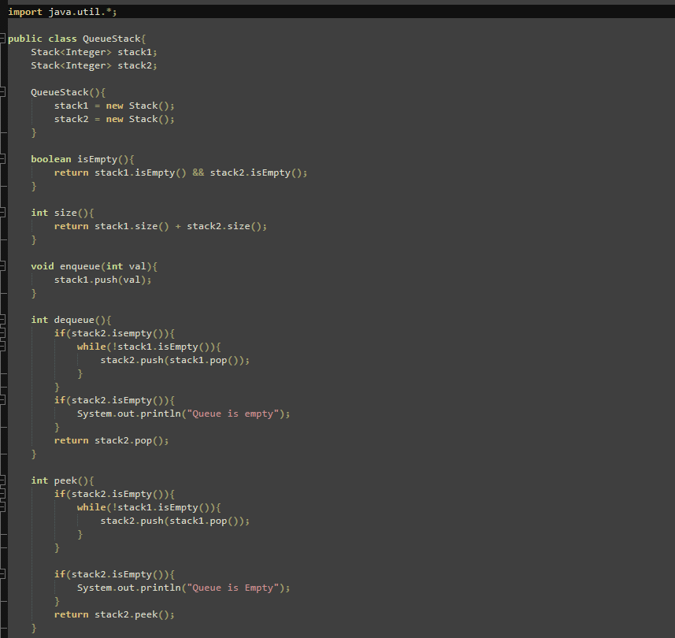

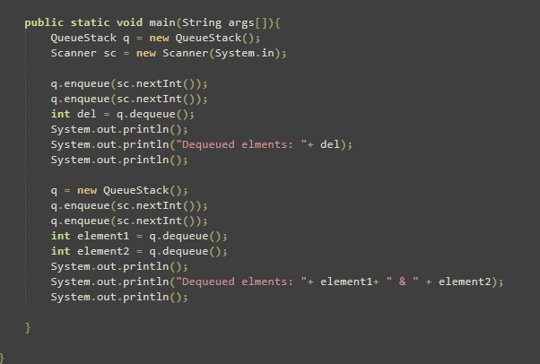

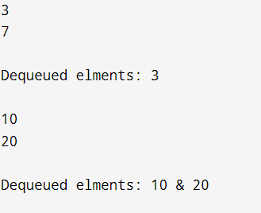

**Flowchart –**

**Start**

**|**

**Initialize stack1**

**and stack2 as empty**

**|**

**Enqueue(value)**

**|**

**Push value**

**into stack1**

**|**

**Dequeue()**

**|**

**Is stack2 empty?**

**/ \**

**Yes No**

**/ \**

**Pop elements Pop from stack2**

**from stack1**

**and push to**

**stack2 until**

**stack1 is empty**

**|**

**Return popped**

**element from**

**stack2**

**|**

**Pop from**

**Stack2**

**|**

**Return dequeued element**

**|**

**End**

**Explanation –** Firstly, I’ve created two empty stacks, stack1 and stack2. When enqueuing an element, it is pushed into stack1. For dequeuing, the process first checks if stack2 is empty. If it is, all elements from stack1 are popped and pushed onto stack2. This transfer reverses the order of elements, and the element that was enqueued first to be on top of stack2. If stack2 is not empty, the top element of stack2 is popped and returned as the dequeued element. This method ensures that the queue maintains the correct order for adding and removing elements.

**Time Complexity:** Enqueue : 0(1) , Dequeue: O(1)

**Space Complexity:** O(n)

**9. Implement a Min-Heap.**

* **Test Case 1**:  
  Input: Insert 10, 15, 20, 17, Extract Min  
  Output: Min-Heap = [15, 17, 20], Extracted Min = 10
* **Test Case 2**:  
  Input: Insert 30, 40, 20, 50, Extract Min  
  Output: Min-Heap = [30, 40, 50], Extracted Min = 20

**10. Implement a Max-Heap.**

* **Test Case 1**:  
  Input: Insert 12, 7, 15, 5, Extract Max  
  Output: Max-Heap = [12, 7, 5], Extracted Max = 15
* **Test Case 2**:  
  Input: Insert 8, 20, 10, 3, Extract Max  
  Output: Max-Heap = [10, 8, 3], Extracted Max = 20

**11. Sort an array using a heap (Heap Sort).**

* **Test Case 1**:  
  Input: [5, 1, 12, 3, 9]  
  Output: [1, 3, 5, 9, 12]
* **Test Case 2**:  
  Input: [20, 15, 8, 10]  
  Output: [8, 10, 15, 20]

**12. Find the kth largest element in a stream of numbers using a heap.**

* **Test Case 1**:  
  Input: Stream = [3, 10, 5, 20, 15], k = 3  
  Output: 10
* **Test Case 2**:  
  Input: Stream = [7, 4, 8, 2, 9], k = 2  
  Output: 8

**13. Implement a Priority Queue using a heap.**

* **Test Case 1**:  
  Input: Enqueue with priorities: 3 (priority 1), 10 (priority 3), 5 (priority 2), Dequeue  
  Output: Dequeued element = 10 (highest priority), Priority Queue = [5, 3]
* **Test Case 2**:  
  Input: Enqueue with priorities: 7 (priority 4), 8 (priority 2), 6 (priority 3), Dequeue  
  Output: Dequeued element = 7, Priority Queue = [6, 8]

**14. Design an algorithm to implement a stack with a getMin() function to return the minimum element in constant time.**

* **Test Case 1**:  
  Input: Push 5, Push 3, Push 7, Get Min  
  Output: Min = 3
* **Test Case 2**:  
  Input: Push 10, Push 8, Push 6, Push 12, Get Min  
  Output: Min = 6

**15. Design a Circular Queue with a fixed size, supporting enqueue, dequeue, and isFull/isEmpty operations.**

* **Test Case 1**:  
  Input: Size = 4, Enqueue 1, 2, 3, 4, isFull()  
  Output: True
* **Test Case 2**:  
  Input: Size = 3, Enqueue 5, 6, Dequeue, Enqueue 7, isEmpty()  
  Output: False